Installing pycryptodome

The installation is not difficult and is described here. <https://pycryptodome.readthedocs.io/en/latest/src/installation.html>

You can use pycryptodome on almost anything that runs Python, so you may choose your operating system (If you like “easy”, choose Ubuntu or Windows for this one.) Please use version 3 of Python. In Ubuntu run python3 to use Python version 3 and python to use Python version 2.

# Install Python3

## Ubuntu

Test whether Python version 3 is installed by typing  
python3

If it is not installed use  
sudo apt install python3

Run Python3 by typing python3. If you use python, you will get Python2

## CentOS

Python3 on CentOS is not nearly as easy as it is on Ubuntu. You might as well use Python 2.7 that is installed by default.

## Windows

Download the current Python version from <https://www.python.org/downloads/windows/> and install it. Note: several students installed more than one version of Python and got confusing results. it is easiest to have one version.

When you install Python, it gives you the option to add Python 3.7 to your PATH environment variable. **DO IT!!** Otherwise you wind up buried in weird directories when you use the command line.  
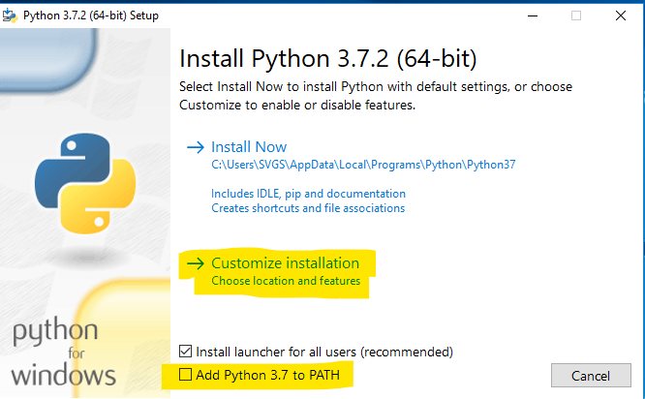

In the custom installation make sure that pip is selected. IDLE is a klunky, but workable Integrated Development Environment (IDE). Maybe calling it an IDE is a little much. Anyway, it can come in handy.  
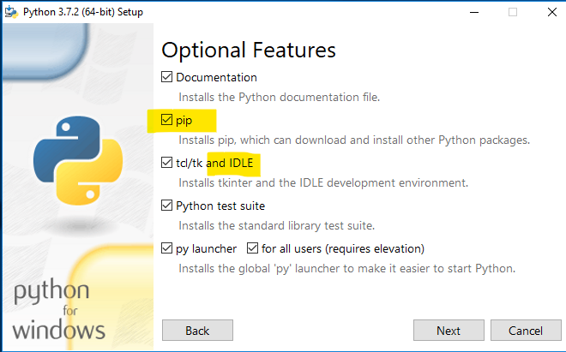

Window has a limit of 260 characters in a file path. Since Python installs itself on a long file path already long (like C:\Users\SVGS\AppData\Local\Programs\Python\Python37\) the limit can cause problems.  
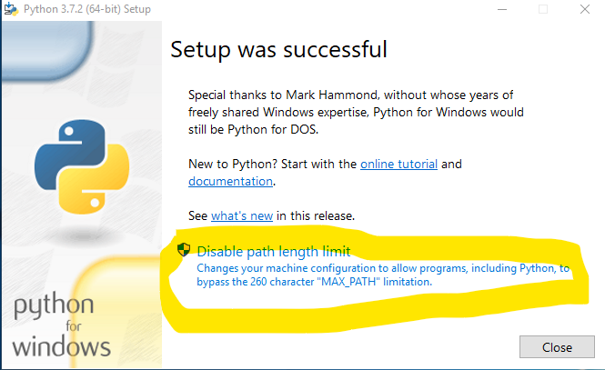

# Install PIP

PIP is the package installer for Python. Once PIP is installed, adding Python modules that support PIP is easy.

## Ubuntu

In Ubuntu, execute  
sudo apt install python3-pip

Test the installation using  
pip3 --version

## CentOS

In CentOS, add the Extra Packages for Enterprise Linux (EPEL) repository, then install PIP  
sudo yum install epel-release  
sudo yum install python-pip

Test using  
pip --version

## Windows

PIP should already be installed in current versions of Python for Windows. If you are having problems running PIP, you may have forgotten to have Python added to your path when you installed Python. If that is so, open File Explorer and find your Python37 (or whatever version) directory. Right now, it is in C:\Users\your-user-name\AppData\Local\Programs\Python\Python37\. Also, the AppData directory is hidden, so you need to set View to Hidden Items. While you are at it, check the box for File name extensions.  
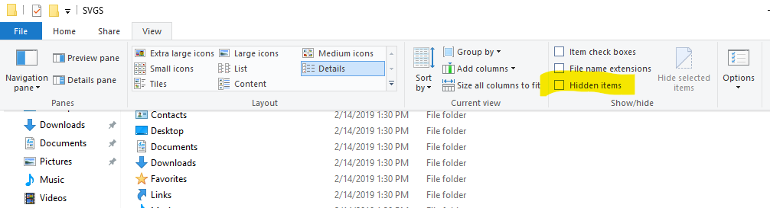

Copy the file path and add it to your PATH variable. Right-click properties of This PC in File Explorer select Advanced System Settings, and Environment Variables. Make sure that you have both the path to Python and the path to the Scripts directory under it. PIP needs the Scripts directory.  
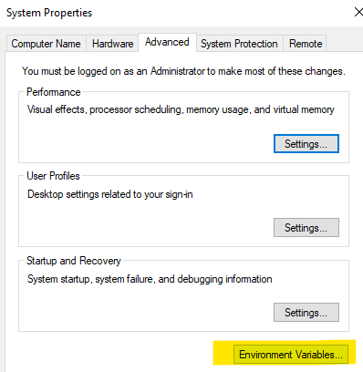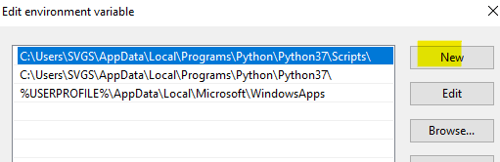

# Install pycryptodome

## Ubuntu

Use  
sudo pip3 install pycryptodome

Test the installation with  
python3 -m Crypto.SelfTest

If you do not get errors, your installation succeeded. The self-test is quite long, so you do not have to let it complete.

## CentOS

Use  
sudo pip install pycryptodome

Test the installation with  
python -m Crypto.SelfTest

If you don’t get errors, your installation succeeded. The self-test is quite long, so you don’t have to let it complete.

## Windows

Use  
pip install pycryptodome

Test the installation with (case sensitive)  
python -m Crypto.SelfTest

If you don’t get errors, your installation succeeded. The self-test is quite long, so you don’t have to let it complete.